ISLAM AND ADAT PRACTICE IN BANDA ISLAND:

Islamic Education Values and Environmental Ethics

in the Traditional Rituals of Banda Naira

Abdullah Latuapo
Institut Agama Islam Negeri (IAIN) Ambon
abdullahlatuapo@iainambon.ac.id

Abstract
Cakalele is generally defined as the “war dance” of Maluku. The movement in the dance clearly shows a pattern of attack as part of a war strategy; this includes jumping, spinning, stomping, and sword slashing. However, the Cakalele of Banda is unique. Its costume, dancer formation, and movements are specifically oriented toward Islamic values and environmental ethics among past coastal communities of Banda. Our study employed qualitative analysis from a phenomenological perspective. The subject was Cakalele dancers, including their attributes and movements. The study took place in the traditional village of Namasawar in Banda Naira District. Findings confirmed that Cakalele contained Islamic teaching values of the sharia and the rituals and the environmental ethics emphasizing harmony between human beings, the coastal area, and the sea. This article proves that Cakalele conveys a strong message on Islamic teaching values and social and environmental ethics.

Keywords: tradition, Islamic education, environmental ethics, Banda island

INTRODUCTION
Historically, Cakalele was a war tradition between villages and islands in Maluku. This tradition was practiced in many islands of Maluku, representing an event of “head cutting” between clans (Aveling, 1967: 356) to show the power and authority of ethnicity in a certain region. A village or tribe would be called great at war if they had Cakalele soldiers. This is why Cakalele is often defined as “war dance” or “war training” since it does portray attacking and defending movements. Philip Winn (2003), citing Bickmore (1868), states that the origin of Cakalele came from a story of an American shell collector who directly watched “a small attraction” in a bay of Nusalaut Island near Saparua in 1856. The collector mentioned:
“… around a dozen native people were wearing their ancestral war costumes. They carried a machete or large sword in the right hand and a narrow shield about four feet long in the left. On their heads were large crowns with feathers, and on their shoulders and elbows were bright red calico cloth. Their war dance consisted of jumping forward and backward and spinning rapidly.” (Bickmore 1868:186 in Winn, 2003:53).

That story then perpetuated the unique movement of Cakalele: jumping back and forth, spinning, and stomping. The dance movements usually follow the rhythm of a tifa, an instrument similar to a drum, which is stroked quickly. The movements and jumps are made while swinging the shield and sword, which is raised in an aggressive, sometimes defensive posture. Cakalele is a kind of symbol of violence or might. The dance is practiced by bare-chested troops with red bandages on their heads, showing both anger and courage.
However, Banda Naira’s Cakalele is unique; the formation of troops (dancers), their clothes and attributes, and their status and role have a specific meaning. Banda Naira has two formations of Cakalele dancers: 5 people and 9 people. Des Alwi (2007), in his book “Sejarah Banda Naira”, states that the 5-dancer formation originates from the traditional group of patalima (also commonly known as ulilima), and the 9-dancer formation comes from the traditional group of patasiwa (also widely known as ulisiwa).
Cakalele is one of the customary rituals usually held in the customary house or “rumah kampong”. Ritual is a technique (way, method) to make a custom become sacred. Ritual creates and maintains myths and social and religious customs because ritual is “religion in action”. Rituals can be done in private or in groups and determine the personal position of performers according to their respective customs and culture. As a nature, ritual is everything connected or involved with religious ceremonies, such as birth, death, marriage, and daily rituals to expose oneself to the sacredness of the event.A customary ritual symbolizes religion and human culture. Symbolic actions in religious ceremonies are necessary. Man must perform something that symbolizes communication with God. Besides religion, customs also have very prominent symbolism in the form of traditional ceremonies hereditary from older generations to younger generations (Budiyono, 2016).
The cultural items, such as the dancer’s clothes, represent the absorption of various social and cultural diversity of nations in Indonesia and the world. The colorful display indicates ethnic origin. This proves that this island has been a world trade destination visited by various nations in the past. Meanwhile, the dance movements show not only movements for war but also important lessons about Islamic law, social ethics, and preserving the coastal natural environment. This paper tries to describe the traditions of the people on Banda Island and shows a close relationship with the values of Islamic education and concern for the maritime natural environment, which is the topography of this region.

THE HISTORY OF BANDA’S CAKALELE
Banda Naira has two groups or models of Cakalele, referring to five and nine alliance groups belonging to Maluku and Seram's local people. Frank L. Cooley mentions that these groups were Ulisiwa and Ulilima in North Maluku, Patasiwa and Patalima in Central Maluku, and Ursiuw and Urlim in Southeast Maluku (Cooley, 1987). Francois Valentijn mentions that the grouping could be originally tracked to the two most prominent kingdoms in North Maluku, Ternate and Tidore (Valentijn, 1721).
However, oral tradition has a different version of the story. The grouping happened due to the separation of three siblings living in Gunung Nunusaku (Seram) after a big flood hit their residence. The three siblings then lived in three different areas. The eldest went to West Seram and his descendant became the Seram Group, the second child went to East Seram and became the Fifth Group, and the youngest went to small islands south of Seram and became the uliate or uliasa group (Alwi, 2005:7).
In Banda Naira, customary villages belong to two big groups: Orlima (the Fifth Group) and Orsia (the Ninth Group). Banda has seven customary villages, five belong to Orilima (including Namasawar, Ratou, Fiat, Selamon, Waer, and Sairun), and one belongs to Orsiwa (Lonthoir). According to Des Alwin (2005), the clan groups were separated due to political competition between the King of Ternate and the King of Sahulau. In the power struggle, the Orlima group then entered into the control of Ternate’s power, and Orsiwa was under Sahulau’s power (see Alwi, 2005:7-11).
The oral history of the Bandanese traditional elders mentions that each customary village has a kin relationship. Desa Ratou, for example, has a kin relationship with three other siblings: Namasawar, Sairun, and Selamon. Meanwhile, Desa Fiat has a kin relationship with Lonthoir. However, other oral records mention the kin relationship of these villages under different names, such as Maulana Kun Fayakun (Raja Lewetaka/Namasawar), Maulana Rasudin (Raja Waer), Maulana Safiuddin (Raja Selamon), Maulana Sahiudin (Raja Rosengging), and Nerr Boi Rattan (Putri or Ratu Ratou).
The kings in each of these customary villages had several bodyguards who became known as Cakalele troops. For traditional villages that adhere to a five-group system, the Cakalele troop consists of five people. Only Lonthoir has nine Cakalele troops. For the purposes of this paper, we will review more about Cakalele orlima from Namasawar in Banda Naira District.

CAKALELE RITUAL AT NAMASAWAR
Desa Adat Namasawar (Namasawar customary village) is administratively part of Nusantara Village of Banda District, Central Maluku Regency, Maluku Province. Its petuanan includes three administrative villages in Neira Island, Nusantara Village, Merdeka Village, and Rajawali Village.
Its customary house, or “rumah kampong”, is in Nusantara Village, which belongs to the fifth group (Ulilima or Patalima). The customary house is the place for the annual ritual procession of buka kampong and Cakalele dance. The ritual for buka kampung starts a week before the main ritual but can also be shortened to two or four days before. The following are the steps in buka kampung.

- Rapat Musyawarah Adat Namasawar (Customary Deliberation)
The people of Namasawar start by inviting guests from the three administrative villages. They also invite customary leaders. This marks the beginning of the ritual; everything is decided in the deliberation. The deliberation recommends the preparation time for buka kampung, usually one week before the event. Buka kampung needs many preparations, such as making tempat sirih, gerbang, and many others. People are invited to work together for the success of the event.

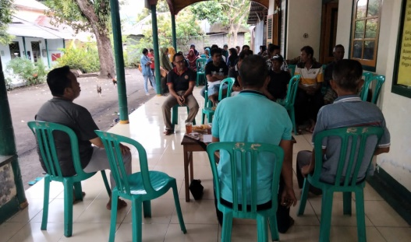

Figure 1. Customary deliberation at Namasawar (Photo by Afrizhal Kepa)
- Task Division in Buka Kampung
Five customary elders, or Orlima Dalam, divide the tasks for buka kampung. Orlima 1 and 2 prepare everything related to kamar puang Cakalele, while Orlima 3, 4, and 5 prepare the instruments, food, and beverages; however, people help each other. Orlima Luar also helps prepare instruments, food, beverages, and other affairs of rumah kampung. They cooperate with each other based on cultural tasks that have been understood together.

- Preparation of Buka Kampung
Since the deliberation starts, it is mandatory to sound lot-lot (tifa) every afternoon at 16:30 at rumah kampung to call for people to gather and start working on the preparation for buka rumah. The preparation includes Cakalele dance practice, cutting bamboo for the gate, maruka (female) dance, and picking up young coconut leaves(janur) for the putar tampa sirih ritual. Tampa sirih is basket-shaped container made of woven young coconut leaves. It is used to place flowers, limestone chalk, gambir, tobacco, and betel leaves when visiting their ancestors’ cemeteries before buka puang.

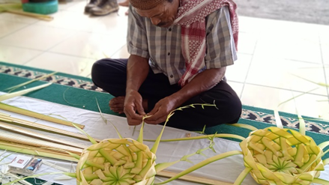

Figure 2. Making tampa sirih (Photo by Linda F.)

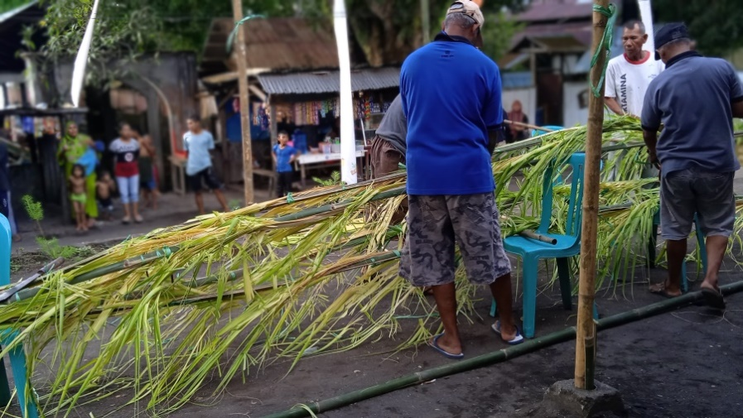

Figure 3. Making gerbang and accessories for puang
(Photo by Linda F.)

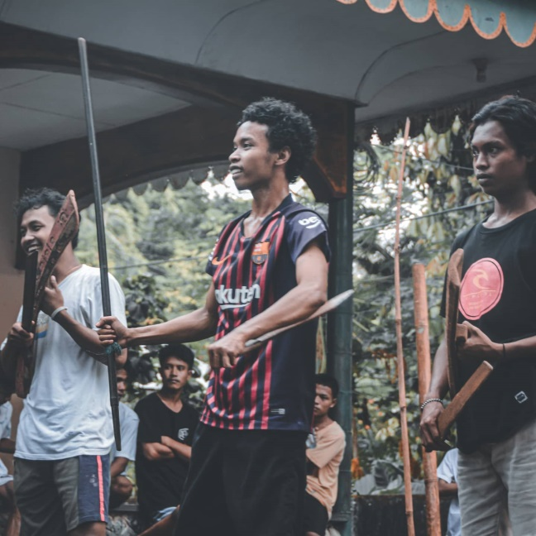

Figure 4. Cakalele dance practice (Photo by Linda F. and Afrizhal Kepa)

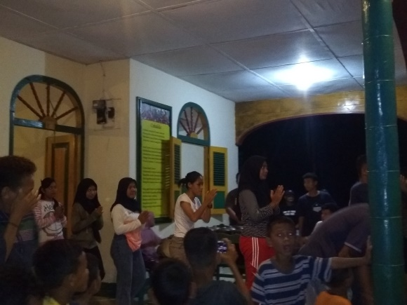

Figure 5. Maruka dance practice (Photo by Linda F.)

The tools and ingredients for buka kampung are (1) young coconut leaves for Tempat Sirih and Tempat Sirih Anak, (2) the filling of Tempat Sirih, including betel nut, gambir, tobacco, limestone chalk, and incense, (3) making Gerbang using bamboo and coconut leaves, (4) Tiwal and Gong Sembilan to call people to chant kabata at the night of buka puang, and (5) machetes, spears, and Salawaku for Cakalele dance.

- Putar Tampa Sirih (The Making of Tampa Sirih)
After preparations, a lot-lot is sounded to call people for Putar Tampa Sirih. The customary elders, or orang tua negeri, lead the activity from 07:30 to 08:00 in the kamar puang of rumah kampong. Kamar puang is the room for keeping the traditional or customary stuff of Namasawar. Since kamar puang is not too big, only less than ten men can enter it, including Orlima and those capable of assisting putar tampa sirih. However, nowadays, putar tampa sirih is done in the front yard of rumah kampong. The activity starts with making 17 big tampa from young coconut leaves and anak tampa as needed.
When the elders men are making tampa, the women prepare the filling of tampa in a different room. The filling of tampa includes betel nut, gambir, tobacco, limestone chalk, and incense. After the 17 tampa are finished, the women can enter kamar puang and fill the tampa for the next day’s grave pilgrimage.

- The Filling of Tampa Sirih
Tampa has two shapes, tampa sirih anak and tampa sirih besar, filled with betel nut, gambir, tobacco, limestone chalk, and incense. In detail, tampa sirih besar is filled with 25 areca leaves, banana leaves, and cigarette or rolled tobacco; all of which are tied using banana leaves and betel leaves and are called sirih lele. There are five sirih lele, and another betel leave is added to create six sirih amba. It is then closed and added with cotton, candles, and the five ingredients in tampa sirih anak. Finally, spread the flower on top of tampa sirih.
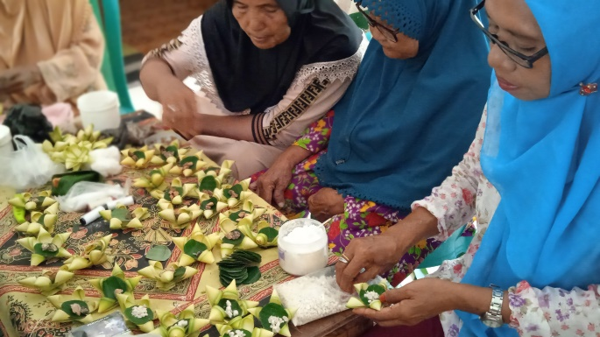

Figure 6. Preparing the filling of tampa sirih (Photo by Linda F.)

- Taking Tampa Sirih for Grave Pilgrimage (ziarah)
The next day after putar tampa sirih, tampa must be taken to the sacred cemetery at 06:00-07:30 in the morning, or at the maximum of 08:00. The people prepare 17 tampa sirih, 16 of which are taken to the cemetery, and one is left for the night of buka puang.
Before going to the cemetery, people pray based on Islamic teachings. They ask for safety during the grave pilgrimage. Around 30 young and old men from the three administrative villages are ready to join the grave pilgrimage.

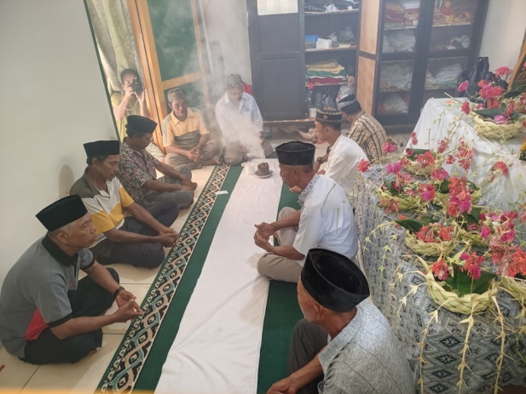

Figure 7. Praying before pilgrimage (Photo by Afrizhal Kepa)

Grave pilgrims are divided into three groups. Group 1 and Group 2 take the land route, and Group 3 travels by sea. Group 1 is led by an Orlima to visit Rumah Adat, Mesang Jadi, Gunung Manangis, Gunung Tujuh, Batu Lanang, and Parigi Laci; this group is called the “Gunung Tujuh” Group.
Group 2 is led by Orlima Kepala and an Imam to visit five cemeteries: Rumah Adat, Kebun Kelapa, Papan Berek, Boy Kerang, Kubor Gila, Kota Banda, Batu Masjid, and Parigi Laci. Group 3 is led by an Orlima to visit Rumah Adat, Gunung Api, and Parigi Laci by the sea.

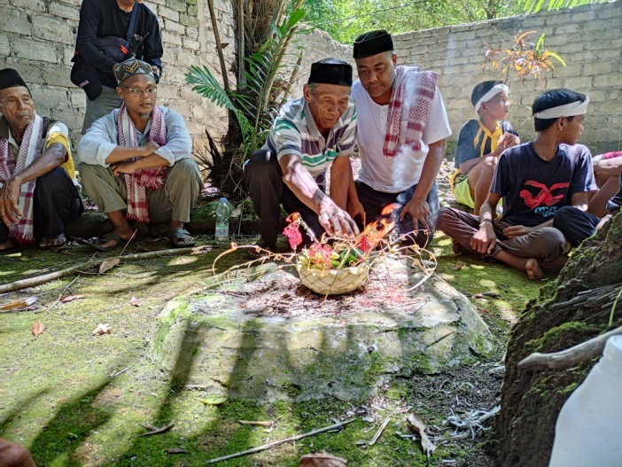

Figure 11. Grave pilgrimage of Parigi Laci (Photo by Afrizhal Kepa)

These groups will meet at one point, Parigi Laci, an old well at Malole shore. They will open the well lid and take the water. They also take the white sand for rumah kampong. After all the containers for keeping water and sand are full, the pilgrims board the boat prepared by Group 3. The pilgrims stop at the last place of their pilgrimage, Batu Basar Pante Kasteng. Upon arriving at Pante Kasteng, a lot-lot is sounded to greet the pilgrims.

- Buka Puang
Buka puang is usually done at midnight, not more or less than that. In the seconds of approaching the buka puang event, the Orlima will turn off the lights around the customary village and ring the lot-lot to signal that the bamboo carriers will come down and enter rumah kampong. There are five bamboo plants used as tiang bendera. Each bamboo has 13 to 17 nodes. Cakalele dancers hold those pieces of bamboo. The 17-node bamboo is held by hulubalang, the 15-node bamboo is held by Kapitan 1 and Kapitan 2, and the 13-node bamboo belongs to malese. The bamboo is then cleaned or bathed before being tied using kain adat at the end of the bamboo.

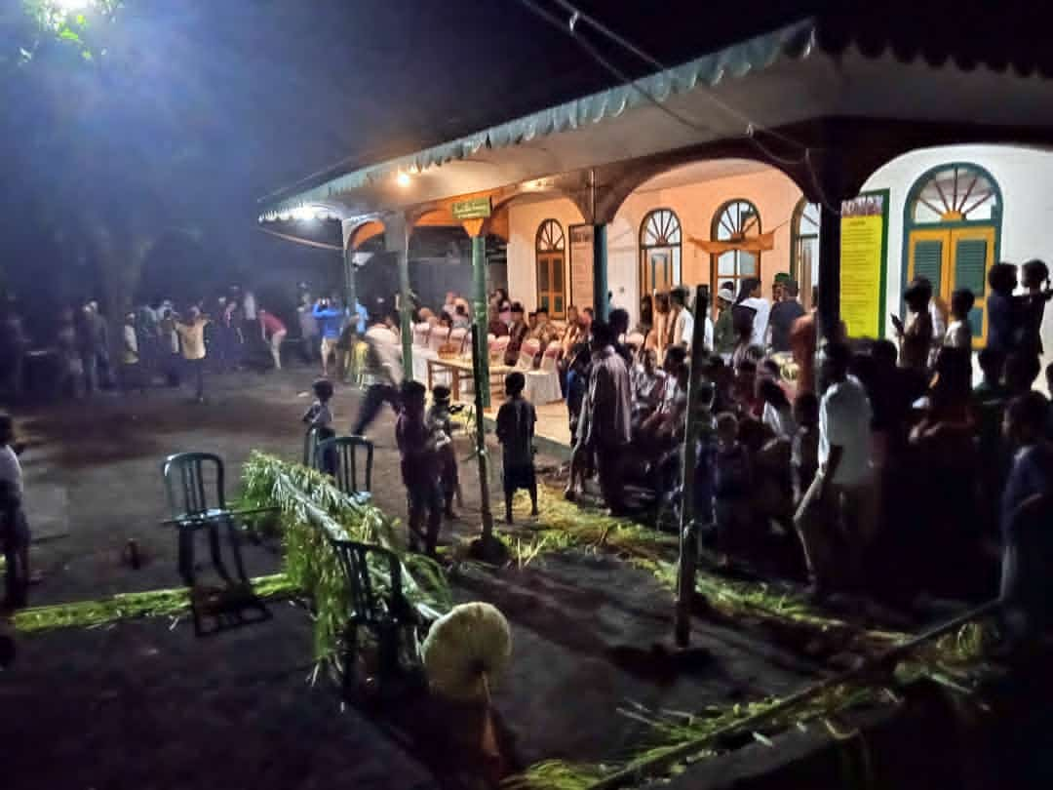

Figure 12. Buka puang procession (Photo by Linda. F)
After preparations, buka puang starts at 10 PM. All Orlima are inside puang cakalele to split mayang kelapa (spatha); when mayang kelapa has been opened, then buka puang starts. From the puang cakalele, a bell is rung three times, signing that all preparations inside the puang are done. Then lot-lot is sounded, and the bamboo (Tiang Bendera), the gate, and the symbol of Naga Namasawar are installed, and the flag is raised. Each home will put a coconut leave on its pillar, tiwal and gong are sounded, and sand is spread in front of rumah kampong; all of these must be done quickly. Then, the Cakalele and Maruka dance is performed.

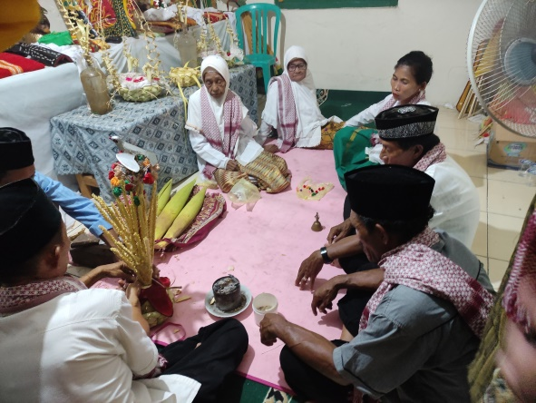

Figure 13. The process of splitting mayang kelapa (spatha) inside puang (Photo by Afrizhal Kepa)

- Cakalele Dance of Namasawar
Cakalele dance of Namasawar consists of five dancers: 2 Kapitan, 1 Hulubalang, and 2 Malesi. Kapitan, Hulubalang, and Malesi wear different attributes, clothes, and accessories. Cakalele dancers usually wear make-up like females. They put on face powder and have their lips red. The red color on their lips is not made with lipstick but caused by sirih lele, consisting of betel leaves, areca nuts, and limestone chalk, rolled in the betel leaves and chewed to get those red lips. Their performance is very artistic and shows that Cakalele is not only a dance, but also a ritual full of symbols and meanings.

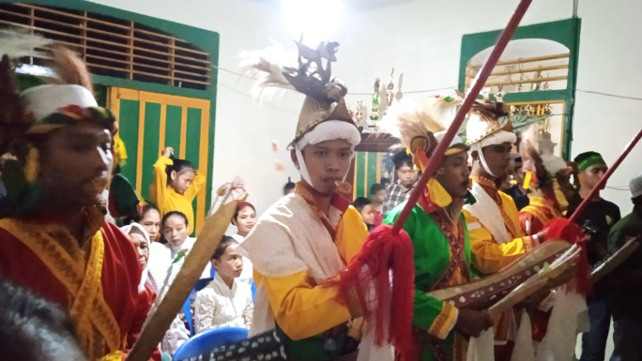

Figure 14. Cakalele dancers of Namasawar (Photo by Linda F.)

Kapitan’s attributes. Kapitan is a commander. He wears green clothes, yellow pants, a red sash, and a red belt, and his hands hold two white handkerchiefs. He uses a kapsete decorated with a Cendrawasih on top of it, one sunting, one machete, and one salawaku (shield).
Hulubalang’s attributes. Hulubalang is the commander’s bodyguard. He wears red clothes, yellow pants, an orange sash, and an orange belt, holding two white handkerchiefs in his hand. His head is decorated with a jester or crown with a Lusi bird on his left side. He has one salawaku and one machete.
Malesi’s attributes. Malesi is the commander’s adjutant. He wears yellow clothes, red pants, a yellow sash, and a green belt. He wears two white handkerchiefs in his hands. His head is decorated with a jester or crown with a Cendrawasih bird on his left side. He has one spear and one machete.
The musical instruments used for Cakalele dance are tiwal, gander, and nine gongs. For dance practice, a different type of tiwal and gander are used.
The Cakalele dance of Ratou only uses five movements. The elders say that Cakalele used to have many movements, but only five are taught: terbang, pikul, jumpot, pikul biasa, and gerakan biasa. There is a forbidden movement in Cakalele⎯the movement must not be put in the dance if a customary sibling is also having buka kampung at the same time. The movement is called slep tumbak, a jumping movement like a bird. The attribute on the bamboo pole is called Kain Patola, tied in five folds. The distance between the Cakalele pole and the other pole is three adult steps.

- Maruka Dance
The Maruka dance is one of the stages in buka kampung. Maruka is the personification of Ratu (the Queen of) Lewetaka from the Kingdom of Namasawar. Maruka is surrounded by five Cakalele troops, dancing together the night after buka puang. The Maruka dance appears along with Natu (people who sing kabata or traditional songs). When Natu chants the kabata accompanied by tiwal and the nine gongs, the Queen will come out of the rumah kampong, followed by the five Cakalele troops to dance in front of the rumah kampong. Then Kapitan 1 enters to call five mai-mai (ladies-in-waiting) to come out and dance with the Queen and the five Cakalele troops.

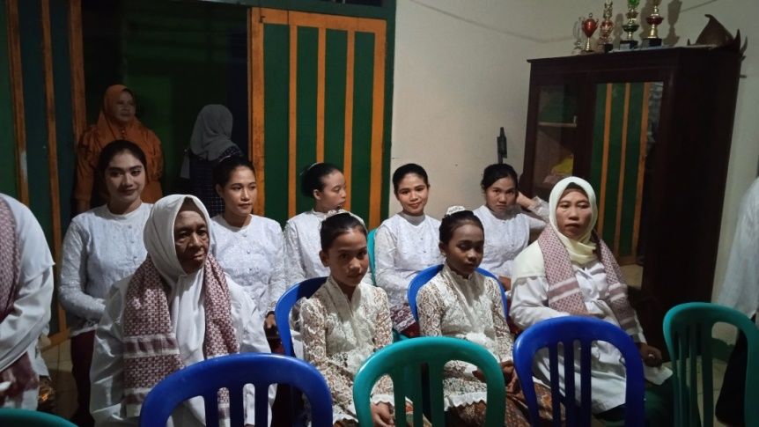

Figure 15. The Maruka Queen with the ladies-in-waiting (Photo by Linda F.)

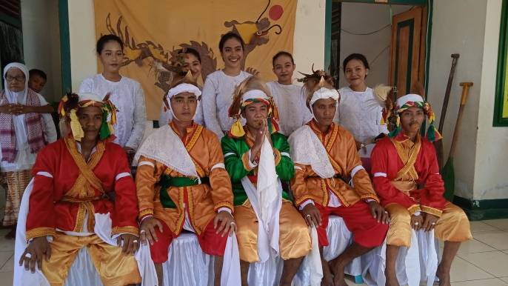
Figure 16. Cakalele dancers with the ladies-in-waiting (Photo by Linda F.)

ISLAMIC EDUCATIONS VALUES
The dance and attributes of Cakalele Banda contain strong Islamic teachings and education values. A phenomenon that describes the characteristics of the Indonesian Islamic tradition which describes Islamic values that have been acculturated with people's habits, as well as the natural environment that surrounds them (Rizal, 2012). As described by Azyumardi Azra (2000: 10), that the values of Islamic education through tradition, describe three characters, first, emphasizing the search for knowledge, mastery, and development on the basis of worship to Allah SWT; second, recognition of human potential and ability or to develop in a personality; and third, is the practice of knowledge on the basis of responsibility to God Almighty, and to humanity.
This phenomenon shows that Islam in Indonesia, especially in the Maluku Islands, is not only artistically attractive, but also easy to practice, because it is integrated with the beliefs and lifestyle of the island people. This forms a cultural model which, according to Anakota and Andries (2021) grows and develops in Maluku society in line with their conditions and characteristics, so as to reveal a very unique form of values and diversity. As seen in the traditions and the symbols of the people of Banda Island.
Kain Patola tied to the Cakalele pole symbolizes the five-time prayers and the victory of religion and custom over the colonialists (infidels). That is why the bamboo pole must be upheld, which symbolizes upholding religious principles.
The Cakalele bamboo poles consist of 17 nodes, 12 of which do not use leaves, and five use leaves. The 12 segments mean the number of rakat in the five-time prayers, and 5 means the daily five-time prayers. The Cakalele dance of Kampung Adat Ratu also consists of 3 Cakalele: Cakalele biasa, Cakalele tiang bendera, and Cakalele cabu tiang bendera. The first Cakalele means war dance, the second is called salwir, and the last means closing or victory.
The distance of each Cakalele pole is three feet (adult size). The white sand on the Cakalele pole in rumah kampong symbolizes a red carpet. The bird on the head of Cakalele dancers symbolizes victory or wealth. Jester of Cakalele dancers consists of five folds, symbolizing five-time prayers, as with Kain Patola. Even the belt of Cakalele dancers also consists of five folds. Cakalele can only be performed under the permission of the customary elders because it is a war dance.
Because the dance is full of religious values, it is understandable that it is sacred and magical. Some historians mention Cakalele as a ”spirit possession” attraction. Caka means ghosts, spirits, and suanggi (similar to a witch’s spirit). Lele means angry. Cakalele seems to involve spirits to possess human souls to be brave to fight the enemies.
However, Cakalele of Banda may have various interpretations. Farid (2020), in his book “Tana Banda”, mentions that some Banda leaders interpret “spirit” in Cakalele not as a ghost (suanggi), but as the spirit of the leaders killed in the colonial era. Before the performance, it is necessary to visit some sacred cemeteries. Then, Cakalele is “searching” for the lost bodies of those killed without any trace. On the bamboo poles that stand upright, there is a bunch of red cloth symbolizing the wounds from the body parts that were cut off. This is why dancers are prohibited from uttering a single word when performing attractions.
From the facts above, it can be stated that the Cakalele of Banda is full of Islamic values, including physical values (‘ahdâf al-jismiyyah), spiritual values (‘ahdâf al-‘aqliyyah), intellectual values (‘ahdâf al-rûhiyyah), and social values (‘ahdâf al-ijtimâ’iyyah) (Latuapo, 2020).
Physical importance can be seen in the dance that relies on physical strength. This aligns with Islamic teachings or Islamic education values that prioritize physical well-being. The customary leaders carefully pay attention to the health of Cakalele dancers. They check on the dancers’ health, ask them to wear clean clothes and forbid them from drinking alcoholic beverages before and after dancing.
Spiritual values are closely related to Islam teachings and ecuations values; the core is faith and obedience to Allah and His messenger. The position of intention (nawaitu, motivation) in carrying out the Cakalele dance is vital. Every dancer must keep his intention solely for the sake of Allah SWT and distance himself from being arrogant and proud. The narrative in the Cakalele dance also reflects the purpose of spiritual education, which contains teachings about the pillars of Islam and faith. The ultimate goal of performing this dance is to form good character (al-‘akhlâq al-karȋmah) in a person who believes and reflects the Holy Quran's teachings and the Prophet Muhammad’s moral guidance.
Intelligence values lead to reasoning to find the truth of God’s signs of power and the messages in His verses. The history, manifested in the Cakalele dance and kabata (poems and traditional songs), is like a big book created by God for human beings to contemplate to gain knowledge beneficial to humanity, not destructive as practiced by colonialism in the past.
Social values shape a good personality, a balanced combination of the spirit, body, and mind. Individual identity is reflected as a human living in a pluralistic society. In Cakalele of Banda, the formation of a Banda human being occurs in a plenary manner which presupposes mental exercise (faith), bodily exercise (physical), and intelligence in the midst of living together with diverse ethnicities, religions, and races in Banda Naira to the present day.

SOCIAL AND ENVIRONMENTAL ETHICS
In addition to the values of Islamic education, the second thing that is very important in the tradition of the people of Banda Island is their love for the marine and coastal environment. The place where the majority of the people of Maluku depend on their lives. Fishing is the main source of income for the people of Banda. Their customary practices include making traditional boats and songs that unite all the people, their environment, and their history. Kabata are what they call their traditional songs which tell the history of their ancestors. In addition, visiting sacred places, bamboo poles, birds and other Banda fauna is very important to convey the intrinsic message of adat.The followings are the social and environmental ethics in Kabata Nawmasawar.

- Appreciating the ancestors
The Bandanese appreciate their ancestors through their customary rituals, songs, and poems called kabata. Some lines of the kabata say the followings.
“Gong seng Gong seng Namasawar Gong seng. Namasawar sawar liling
sawar liling ee”
Meaning: (Greetings and respect for the ancestors of Namawasar).
This sentence is the opening of buka kampung ritual before the Cakalele dance. This is obligatory as a way to greet the ancestors. The King passes on the custom to the present time.

- Respecting women
In addition to the King, kabata is also a respect to the Queen, known as Ratu Maruka, as written in the following line:
“Boy e, Boy e, aku somba Boy e. Maruka namasawar aku somba Boy e”
Meaning: We pay our respects. To the reigning queen.namasawar, we pay our respects.
Somba literally means to worship, but it does not mean to worship God. It is an appreciation and respect to the Queen, Ratu Namawasar, as a child-bearer of Banda. It is interesting to note that the word somba is addressed to a woman (mother) and not to the King since women were the only successor to Banda after the genocide by VOC in 1621. Historically, the Banda war happened from 1609 until 1621 and ended in the massacre of 14,000 Bandanese, of the total 15,000 Bandanese. After the genocide, the 1,000 Bandanese left were mothers and daughters (see Joella & Farid, 2020; Farid, 2018:105-113).
The following kabata lines show how women become a symbol of honor, dignity, and self-esteem for the Bandanese.
“Rete rete, rete ratu nairan. Nairan sunting bunga kambang campaka e”
Meaning: that saves the honor of Queen Naira.

There is also an epic where a woman is expelled from her homeland, but because of her dignity, later on, she is highly respected to become a Queen, as the story in the following kabata line.
“Boi rattan timbang tana timbang apa lelekala. Tarusauh kelemuri
angka raja ole”
Meaning: the one that is exiled because of honor and prestige. Until she arrives in the land of exile and henceforth becomes a just ruler.
The story of Boi Ratan in the Bandanese oral tradition is a fragment of a story of a holy woman from Banda who was slandered and then expelled from her country. The woman arrived on a very foreign island (a spooky island, some say Ambon) that already had a King who was amazed by the beauty and nobility of the woman and decided to marry her. Their children and descendants are the people of Maluku today. The woman later became the successor to the King and led the islands in Maluku fairly and dignifiedly.

- Respecting other beings
Kabata of Banda also mentions respect to some animals, including pigeons and endemic birds of Banda, such as in the following line.
“Walange walange marapati walange. Marapati lewetaka, lewetaka ee”
Meaning: The Kingdom of Lewetaka, the home and place for pigeons to gather.

This verse shows that the Kingdom of Lewetaka is the place or home for all pigeons to gather. Images of the species can be found in several traditional attributes, such as boats and Cakalele dancers. This shows how close and harmonious the customs and the surroundings (fauna) are. Besides that, there is also mention of the names of local birds, the Baikole bird, as in the following line.
“Ole-ole burung baikole, tarabang sini sana burung baikole”
Meaning: who is brave at war, fighting the enemy like Baikole dancing on the ground.

Baikole is also known as Willie Wagtail or kipasan kebun. They are found in coastal areas, riverbanks, and lowlands. Baikole also means sway butt. They have such beautiful tweets and love singing in the morning when the sun shines brightly or after the rain. They love singing all the time. The color of the fur from head to tail is black with the lower part of the chest, belly to tail, is white, and has a long white stripe on the eyebrows. Its nest is like a bowl, 8-10 centimeters in diameter, made of grass, but very tightly woven, neat, and sturdy. Baikole is brave and fond of preying and perching on branches and risky places. The philosophy of Baikole in kabata means beauty coupled with strength, courage, and solidarity.
There is also a dragon mentioned in kabata.
“Nairanbese besetiris tirise. Tiriso yo malela ular naga nairan”
Meaning: Respect to the dragon ship, a symbol of the ruler of the sea of Banda Naira.
The dragon symbolizes glory and the ruler of the sea. In the Namasawar custom, the dragon becomes the main emblem in the dragon boat (kora-kora), which denotes the ruler of the seas of Banda Naira.

- Respect for the sea inhabitants
Kabata of Banda positions the sea as a territory of power that must be guarded. Several poems even mention that the rulers of the sea stay in Banda waters.
“Lusi ooo Ronda laut yo tantara nairaaan”
Meaning: The army of the rulers of the sea surrounding the entire region lies in the waters of Naira.
This includes marine biota such as sharks, which has a kin relationship with the Banda people. Sharks are called by the local name Yo or Eyo, as in the following verse.
“Dua yo kapitang kora-kora lewetaka. Siku-sikuruma ke belang urulima e
Meaning: Dua yo (warlords) who lead the troops on the boat during the war.
It is possible that the use of sharks as “warlords” or “commanders” is to show the greatness of the two commanders (illustrated in Cakalele and the personnel of the dragon ship) that lead the troops of Lewetaka.
Kabata even mentions stones on the beach in its line.
“Batu kapasete batu gong gai e”
Meaning: This is the stone of those who have witnessed the greatness of the commanders of Namasawar.
The mention of stones shows the importance of the relationship between human beings and the coastal environment, including stones, sand (sprinkling sand on the ground where Cakalele is performed), fish, and the sea. The above meanings illustrate that the people of the Maluku islands including Banda view caring for harmony with nature as a form of cosmic balance that must be maintained, so that nature and humans can continue to live side by side. Maluku anthropologist Alohiat Watloly (2010), calls it an ecological spirituality that plays an important role in the culture of the Maluku people.

CONCLUSIONS
The study of cakalele dance discussed in this paper shows that there is a close relationship between Islam, tradition and the natural environment. Historically, the Cakalele dance was a war dance. The dance, however, functions to welcome guests today. This dance is often performed in many cultural programs. The signature of the dance is the presence of the Queen, or Ratu, representing a female figure wearing bright clothes, lipstick, and eyeshadow and carrying an umbrella to protect herself from the sun. Within Islamic education, the Cakalele dance contains important Islamic values for the Bandanese to train their body, mind, and soul to live in harmony with others of different races or religions. This aligns with the main objective of Islamic education.
Banda customs are also closely related to the coastal and marine environment. The cultural practice of Banda custom includes building a customary house, arranging flowers, and visiting each other. All emphasize the harmonious relationship between the Bandanese and their sea, forests, and coastal areas. Kabata, Banda’s traditional songs, tell stories about their ancestors and convey important messages on preserving the forests, the endemic fauna, the sea, the fish, and even the stones and sand on the beaches.

REFERENCE
Alwi, D. 2005. Sejarah Maluku: Banda Naira, Ternate, Tidore, dan Ambon. Dian Rakyat
Alwi D., Farid, M. 2007. Sejarah Banda Naira. Penerbit Pustaka Bayan, ISBN 979-3766-05-0 Malang
Anakota, Elka, 2021. “False Consciousness: The Cultural Identity Construction of Cele and Batik Within Moluccan Scholars in Ambon,” AL ALBAB: Volume 10 Number 1 June 2021
Azra, A. (2000), Renaisans Islam Asia Tenggara: Sejarah Wacana dan Kekuasaan, Bandung: Rosdakarya
Aveling, H. G. 1967. Seventeenth Century Bandanese Society in Fact and Fiction:'Tambera'Assessed. Bijdragen tot de taal-, land-en volkenkunde, (3de Afl), 347-365.
Budiyono, D., & Soelistyari, H. T. 2016. Evaluasi kualitas visual lanskap wisata Pantai Balekambang di Desa Srigonco, Kabupaten Malang. Jurnal Lanskap Indonesia, 8(2), 81-90.
Cooley Frank, L. 1987. Mimbar dan Tahta, Hubungan Lembaga-Lembaga Keagamaan dan Pemerintahan di Maluku Tengah. Jakarta: Pustaka Sinar Harapan.
Farid, Muhammad. 2021. Tanabanda: Esai-Esai tentang Mitos, Sejarah, Sosial, Budaya Banda Naira. Penerbit Prenada Media, Jakarta
Farid, Muhammad. 2018. Genosida 1621: Jejak Berdarah JP Coen di Banda Naira. In Prosiding-Seminar Nasional Banda Naira (pp. 105-113).
Farid, Muhammad. 2018. Fenomenologi: dalam penelitian ilmu sosial. Prenada Media.
Overgaard & Zahavi, 1996. Phenomenological Sociology - The Subjectivity of Everyday Life, in Hviid, Jacobsen, m (ed.), 2009. Encountering the Everyday: An Introduction to the Sociologies of the Unnoticed, Palgrave Macmilan Basingstoke, p.93-115.
Rizal, Nanang. 2012. “Kedudukan Seni dalam Islam”, Tsaqafa:Jurnal Kajian Seni Budaya Islam, Vol. 1No. 1(Juni, 2012), 1.
Schutz, Alfred. 1967. The Phenomenology of the Social World. George Walsh: Northwestern University Press.
Wilson, T.D., 2002. Alfred Schutz, Phenomenology and Research Methodology for Information Behavior Research. ISIC.
Winn, Phillip. 2005. “’Tanah Berkat (Blessed land)’; The source of the local in the Banda Islands, Central Maluku”, in: Thomas Reuter (ed.), Sharing the earth, dividing the land: Land and territory in the Austronesian world, pp 113- 133. Canberra: ANU Press
Valentijn, François. 1856-58. Oud en nieuw Oost-Indiën. ’s-Gravenhage: H.C. Susan, H.C. Hzoon. Three vols.
van Donkersgoed, J., & Farid, M. (2022). “Belang and Kabata Banda: The significance of nature in the adat practices in the Banda Islands”. Wacana: Journal of the Humanities of Indonesia, 23(2), 415-450
Watloly, A. 2010. Filsafat Masyarakat Kepulauan. Ambon: Pascasarjana Unpatti.

