VALUE IN MALAY COMMUNITIES IN PONTIANAK

Eni Desiyani
Perguruan Al-Mumtaz Pontianak
Email: desiyani_eni@yahoo.co.id

HIGHLIGH
- Islam and Local Culture
- Tumbang Apam culture
- Islamic Education’s value
- Malay Pontianak

ARTICLE HISTORY |  |  | ABSTRACT
Submitt | : | 05 March 2018 | Culture comes from the creative process of humans for their good. The change process is a selection process so that it finally produces the best form. This article will reveal the form of Tumbang Apam culture in Malay society in Pontianak. Data was taken through an interview with a number of cultural actors in Pontianak. The researcher concluded that in the Tumbang Apam cultural activities in Malay communities in Pontianak there were educational values. Through this activity every family member and community are taught to help each other, communicate and strengthen friendship relations. This activity is maintained because of the importance of these values ​​for next generation.
Revision | : | 24 April 2018
Revision Minor | : | 2 May 2018
Accepted | : | 5 May 2018
Published | : | 01 June 2018
 |  | Keyword : | Tumbang Apam, Malay Culture, Pontianak, Education Value
 |  | ©2018 Khatulistiwa All Rights Reserved

PRELIMINARY

Culture is something inherent in human life. Thus, only human beings have culture. Ownership will lead them to the stage of designing and implementing what is best for them.
Culture is the result of a process or product of human thought. Humans try to find the best for their lives. The culture today is in several respects different from the same culture in two generations (grandparent’s generation).
Therefore, every generation has its own culture. They inherit the culture of the previous generation, but, they also create what is in them.
Not surprisingly, then the cultural form changes according to time and generation, even, the space. There are already several writings showing cultural differences between one community and another, even though they are of the same religion and ethnicity, or they are of the same origin, but live in different geographical and political areas (Barth, F, 1982, Yusriadi, 2014).
Of course this view does not rule out the possibility that there is a problem of cultural acceptance in society at the same time. For example, certain cultures are practiced by certain families and not on other families even if they live next door. There are also people who reject the presence of culture by expressing the rejection, so that rejection becomes the theme of community discussion.
This article will discuss one of the forms of culture that exists in some communities in the city of Pontianak. This culture is not carried out by the whole community because it is considered irrelevant or is considered out of date, for some people.

RESEARCH METHODOLOGY
This research is qualitative research. The data used in this paper was taken through interviews with a number of cultural actors who were uprooted, and observations on the event of Tumbang Apam in the city of Pontianak, in 2015.
The collected data is described according to the needs of the research, which is related to the form of culture, property, people involved and the purpose behind this activity. Then, this data is analyzed according to the perspective of Islamic education, to see how these cultural activities from the point of view of Islamic education.

DATA AND DISCUSSION
Pontianak Malay tribe
The Pontianak Malay tribe is identification for people living in Pontianak, who claim to be Malay, Muslim and have Malay customs. This needs to be emphasized because Pontianak Malays are actually "mixed" from various regions and tribes. Pontianak as a capital city of West Kalimantan accommodates many people who come from various regions, from diverse backgrounds. (Arena Wati, 1982; Abror, 2003).
Pontianak is also a center for meeting various cultures so Pontianak culture according to Salim Haitami is unique, different from Malay culture in northern Sambas, or southern Ketapang, and Sintang. He gave the term Pontianak as a melting pot from various cultures of the archipelago (M. Haitami, 2013).
They are spread in various residential areas in urban areas. The main, and old settlements are along the sides or edges of the Kapuas River; covering the area of ​​the Palace, Tambelan Sampit, Kampung Kapur, Kampung Cambodia. Now, along with the development of residential areas, Malays also spread in the Siantan region, Kota Baru, Sungai Raya and Jeruju.
The number of Malays in Pontianak cannot be ascertained, because there is no statistical data regarding the population based on ethnicity. But, in general view, they are the dominant group in the city of Pontianak, besides the Chinese. Everywhere Malay people can be found.
The dominance of the number of Malays can also be measured from the use of Pontianak Malay language, as a feature to identify this community group. Malay is the main language, used by Malays, and also almost all residents of the City of Pontianak.
Symbolically, Pontianak City is also a Malay region with the presence of the Pontianak sultanate (Hasanudin, 2014, 2016). This Sultanate is the most important part that shows symbolically the dominant Malays and plays an important role in this city.
Malays in Pontianak practice Malay customs. Customs here are actually not much different from the customs of Malays in general: those who practice Islamic principles as a joint of custom and culture. (Purba, et al. , 2014). Customs relating to the life cycle are practiced by the Malay community, among others around birth, marriage, and death.

Tumbang Apam Procession
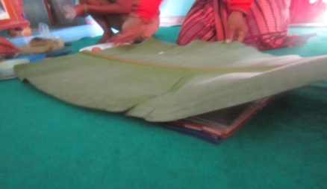
Tumbang apam is a Pontianak Malay cultural custom related to the birth of a child. For Malays, the birth of a child is very grateful and guarded by various efforts. This custom is called tumbang apam because the main ingredient needed is apam. Apam is a culinary name - it will be explained next.
For the implementation of this downfall, Malays who use coconut midribs that have been stabbed by cakes and at the peak are candles or cloths that are lit as symbols of life to open a new life cycle. Coconut fronds that have been plugged in and given the candle are circled to babies and parents as gratitude for the birth of a baby.
The procession was followed by a meal together by a large family and close neighbors. The apam eaten was apam which was specifically provided to be presented to the invitation. So, what is different from what is used for processions - not what is sticked with sticks.
The procession was held the first time in the morning before the invited guests. The tumbang apam is done only for families and is led by someone who is elder in the family. Equipment for this procession itself includes:
- The coconut sheath that was left a little covered for the place where it was stuck.
- What are the two colors, usually the red and white colors that symbolize in every life, there will definitely be couples and there will be opposites such as rich poor, old young, happy and sad.
- The seven-layer cloth, each of which contains coins and yellow rice, symbolizes the sustenance that the child will get, which is expected to be layered and full of blessings.
- Candles / fabrics that are burned at the end of the midrib as a sign of lighting the way in the new life cycle of the child.
- Banana leaves, which are used to cover when served.

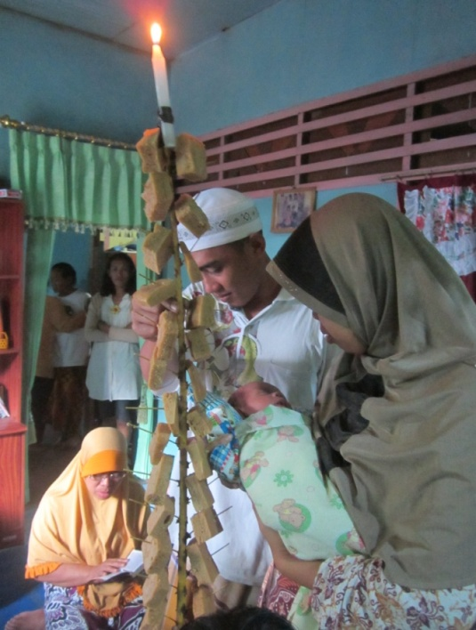
First and foremost in the procession the baby and his parents were told to stand up and step on seven pieces of cloth that had been given change and yellow rice with the top layer covered with banana leaves, then in the middle between the father and mother the coconut fronds were placed the one at the end is given a burning candle. While holding the midrib, it starts to be stabbed in red and white with a puncture between the red and white with an odd number.
During this stabbing procession, a family member recited Surah Yasin and when the Yasin recitation was finished the coconut midrib that had been filled around the baby and his parents in the middle of the fabric to the right three times and rotated to the left three times . After being rotated, it was dropped to the four corners of the wind and the fire was extinguished and the charcoal was applied to the baby's forehead so that the lighted candle could transmit bright thoughts (intelligent) and bright behavior and character (behave well). After the procession is complete, then proceed with a procession of fresh flour in a sitting position.

Material and Method of Making Apam
The ingredients needed to make the apam are: 1 kg of Wheat flour / rice flour/ 1/3 Wrap, 1 kg of Sugar, ½ kg Brown sugar, ½ Kg (red apam) and 1 seed of egg.
First they have to make dough with enough water, and then slowly add the flour. After that, add the eggs and sugar to mix well until it's liquided like half an hour of water. Then put into the steamed pan until done. Eat it mixed with grated coconut that has been mixed with salt.

Tumbang Apam Link with Islamic Education
The tumbang apam is a culture of society that they inherit to express expressions of gratitude for the birth of the baby, as well as part of the prayers and hopes for the safety and success of the child in the future. In this culture there is a blend of local culture and Islam. These elements can be seen from the choice of reading surah Yasin's and prayers on one side, and on the other side, there are fire, candles, yellow rice, and others.
These sides are often seen in terms of theology; so that there is an assumption that this custom is not true or violates the Shari'a. Some see this custom as deviating from Islam because it was not carried out by the Prophet.
However, on the other hand, this devastating event has a useful value for Pontianak's Malay community. From the philosophical element, it has a lot of good things. For example, behind this event parents or cultural stakeholders hope that the child is expected to have a good future, prosperous life and healthy family. They, parents and family, pray together that the newborn baby will become a good child. The hopes are united and thundered through the event of a Tumbang Apam tradition.
In addition, the implementation of Tumbang Apam tradition was important to be preserved as a culture, because it contains values and revive hopes for the future of children by always expecting the blessing of Allah SWT.
As we know Islam entered Indonesia through peaceful means not through war and military expansion, therefore by people who spread Islam in Indonesia the cultures of its citizens indirectly on earth scorched but were slowly Islamized by the preservation of culture itself in terms of this is society in ethnic groups. (Kuntowidjoyo, 1987)
The form of Islamization that we can see in this Tumbang Apam culture is the recitation of Surah Yasin at the time of the beginning of being plugged to completion, this culture also teaches us to respect families especially those who are elder in a family, as a whole this culture teaches the importance of friendship and presence family to visit his family so that family ties are not interrupted.

CONCLUSION
Culture is the result of human creativity, initiative and taste (Ihromi, 1987). Culture is something that is very complex including everything, so that culture cannot be separated from one aspect and another aspect. Malay ethnic culture is also a local wisdom that must be preserved by the tribe's successor. The obligation is preserved because the culture contains good values ​​and positive values ​​for people's lives, especially in the context of relations between people.
All traditions in all tribes are fundamentally very interesting, including the tradition of Tumbang Apam. This tradition survives amid the lives of Malay people in the city of Pontianak because it contains elements of education. There is an educational value that sometimes can meet the needs for the survival of life and community relations.
The culture illustrates how Indonesia can live in harmony with its multiethnicism and mutual respect for these differences. We should be grateful to have been born in a country that is rich in cultures, and it is hoped that by learning the culture of each tribe we can be the heirs of culture and local wisdom of our own tribe.

BIBLIOGRAPHY

Abdurrahman, A. (2003). Pantun Etnik Malay Pontianak. Disertasi, Universiti Malaya, Kuala Lumpur.
Arenawati. (1982). Syair Perang Cina di Monterado. Bangi: Penerbit UKM.
Hasanuddin, H. (2016). Politik Dan Perdagangan Kolonial Belanda di Pontianak. Patanjala: Jurnal Penelitian Sejarah dan Budaya, 8(2), 203-218.
Hasanuddin, H. (2014). Pontianak Masa Kolonial. Yogyakarta: Penerbit Ombak.
Ihromi, T. (1987). Pokok-pokok Antropologi Budaya. Jakarta: Gramedia.
Kuntowidjoyo, K. (1987). Budaya & Masyarakat. Yogyakarta: Tiara Wacana.
Purba, J. dkk (2014). Sejarah dan Perkembangan Kebudayaan Malay di Kalimantan. Pontianak: STAIN Pontianak Press.
Yusriadi, Y. (2014). Alam dan Budaya Lokal. Pontianak: STAIN Pontianak Press.

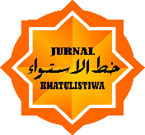 | KHATULISTIWA  Journal of Islamic Studies  Institute of Research and Community Service (LP2M) | P-ISSN | 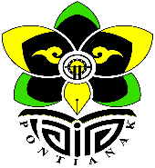  : 1412-5781
 |  | E-ISSN | : 2502-8499
 |  | Volume 8, No. 1 March 2018
DOI :

WEDDING CULTURE OF URANG SERAWAI SINTANG

Oleh : Debi Fajriati
Sekolah Tinggi Ilmu Kesehatan YARSI
Email: debi.fajriati.1991@gmail.com

HIGHLIGH
- Wedding Culture
- Serawai, Sintang
- Malay of Rural Areas in West Kalimantan
- Islam and Local Culture

ARTICLE HISTORY |  |  | ABSTRACT
Submitt | : | 05 March 2018 | This article describes the urang Serawai bride culture in Sintang District, West Kalimantan. The description was carried out because the author was interested in seeing the form of bride culture in Muslim communities living in remote areas which is far from the center of Islam. The data used in this paper is based on interviews with cultural actors and observations of wedding activities in 2015, coupled with own experience as part of the Serawai community. In the Urang Serawai bride culture there is a series of activities. In the activity, it shows the elements of Islam, such as reciting the Koran, prayer, barzanji, hadrah, etc.; and there are local elements, for example, seen in parade, nopen, janur, etc. Through the bride culture, it appears that Islam and local culture are side by side, filling in the space and function of each.
Revision | : | 24 April 2018
Revision Minor | : | 2 May 2018
Accepted | : | 5 May 2018
Published | : | 01 June 2018
 |  | Keyword : | Wedding Tradition, Islam, Local Cultuter, Serawai, Malay.
 |  | ©2018 Khatulistiwa All Rights Reserved

PRELIMINARY
Local culture that lives and develops in an area always shows its characteristic. Local characteristics will be seen from the use of local materials, and the difference becomes clearer when compared to similar cultures that exist in other communities.
In addition, as part of the results of thinking and though human mind, local culture also always shows a mixture with global values ​​and culture. As far as being considered living in a remote, isolated area, difficult to reach, even in the rural area, local people are still able to show that their culture is not calm from other cultures. In the local culture there are still external elements that enter and are accepted, chosen and used in their lives.
Religion is one of the many elements that color the local culture. Many spirits of cultural change occur because of the influence of Islamic religion (Tibi, 1999). In Malay society, or people who are Muslim, elements of the Koran, Hadith, or even culture in Islamic societies, are more common.
In Kapuas Hulu, West Kalimantan, the meeting of Islam and science resulted in the Islamization of knowledge (Hermansyah, 2010). Then there are the terms white magic and the science of heat. There are also lafaz that come from Islam in local spells.
Faizal Amin (2013) also introduced hybrid Islam to see a mix between the two elements - local elements and Islam. This form shows that Islam compromises with local values, thus forming like a different face of Islam. It is precisely Islam like this that is more easily accepted by society. Or, at the very least, Islam does not cause conflict or new problems in the people who accept it.
This article discusses the marriage of Islam and local culture. Data was taken from the Sintang rural area, precisely in the Serawai area. The author conducted interviews and observations in 2015. This data was actually used for making assignments for Islamic courses and Local culture, but was later reprocessed and done into the material of this article. To complete it, the writer uses documents to see how these two elements are seen in the bride culture.

RESEARCH METHODOLOGY
This study aims to describe and analyze marriage activities in the community of Serawai, Sintang. This research was conducted in Serawai, Sintang. Serawai may be considered a remote area in Sintang. This area is difficult to reach from Sintang. To reach this area it takes hours.
Because of its remote location, the outside influence on Serawai was rather small. Traditional cultures are still being carried out. One of these traditional cultures is marriage. A unique marriage encourages researchers to choose this theme.
The research data was obtained from community leaders and cultural actors. Community leaders are considered to know and can explain marriage activities, while cultural actors are seen as providing an overview of the implementation, procession and property for activities. In addition, because the researcher is from Serawai, a little more information about what was needed in this study was obtained.
Furthermore, the data that has been collected is presented with an analytical descriptive approach, to fit the purpose of this study.

DATA AND DISCUSSION
General Potret’s of Serawai
Sintang is one of the regencies in West Kalimantan, the Regency has an area of ​​21,635 km² and has a population of ± 365,000 people. It has 14 sub-districts with the majority of the population are Dayak and Malay tribes.
One of the sub-districts of the 14 sub-districts is Serawai sub-district. This sub-district is a district located next to the downstream of district of Ambalau and next to the district Menukung. The district capital is located in Nanga Serawai in the form of a tanjung, which is formed by the bend of the Melawi River. Sintang Serawai distance through the Kapuas River to the Melawi River is about 200 km or 6 hours away, using a Speedboat. But at this time the Sintang Serawai trip can be reached by road by car or motorcycle.
Although it has a relatively far distance, the two regions have cultures that are not too different. There are various cultures in the area one of them is the Bridal culture. Bridal culture is a culture that is carried out when going to hold or carry out a wedding reception. The author notes that of the 14 districts in the regency. They have a culture which is not far different. But in this paper, author focuses more on the Bridal culture ini Serawai people because of the geographical location of Serawai is that the geographical.
The early history of the Sintang Kingdom began when a man named Malay Aji came to the Kujau area around the 4th century AD. The hand of the Malay Aji turned out to bring Hindu culture into the Malay realm in West Kalimantan, especially to the Sintang area. In Kujau, the Malay Aji married a girl named Putung Kempat and was blessed with a daughter named Dayang Lengkong (Syahzaman & Hasanuddin, 2003: 15).
The establishment of the Sintang Kingdom, which at that time was still Hindu, was able to attract residents around the Nanga Lawai area to come and establish new settlements. The development of settlements around Nanga Lawai turned out to attract the attention of Patih Logender from Singasari Kingdom who at that time participated in the Pamalayu I Expedition in 1275 AD (MD Mansoer, et.al., 1970: 51).
The last king when the kingdom of Sintang was still under Hindu influence was Raden Purba. Raden Purba ruled in the Sintang Kingdom until around the end of the 18th century, along with the influx of Islam to the Sintang and Kapuas Hulu Kingdoms . Before he passed away, it was mentioned that Raden Purba had embraced Islam (Syahzaman & Hasanuddin, 2003: 29).
If seen from the history of the kingdom of Sintang by Aji Malay, so he was carried the Buddhist culture. The author argues that the existing culture at that time have also been influenced by the Buddhist culture that developed at that time. One of the cultures that the writer sees has also been influenced by Buddhist culture, namely the culture of brides, whose culture is not only carried out by the people in the Sintang area, but also spread to other areas including the Serawai area.

Entry of Islam and Change in Society
The process of entering Islamic culture into Sintang, believed to be through the flow of the Kapuas River . Furthermore, the distribution is carried out through this river to the areas of Tayan, Sintang , and Nanga Pinoh. From the Sintang area, Islamic da'wah traveled along the Kapuas River to the Putussibau area. This spread lasted around 1500 - 1800 AD (Yusriadi & Patmawati, 2006 ).
Islamic influence began to enter the kingdom of Sintang when the kingdom was ruled by Raden Purba. After Raden Purba died, the throne of the Sintang Sultanate was held by Adi Nata with the title Sultan Nata Muhammad Syamsuddin Sa'adul Khairiwaddin. Sultan Nata is the son of Mangku Malik and Nyai Cilik (Pangeran Tunggal's sister).
Sultan Nata's government was characterized by various kinds of fundamental changes. The most significant change is the changing form of the kingdom into the sultanate and the arrangement of the sultanate's laws (Syahzaman & Hasanuddin, 2003: 30).
The entry of Islam into this area affects the culture that exists in the area, the culture that was previously packaged and incorporated the nuances of Islam into it. According to the author's observation, the culture of the bride and groom in this area is also one culture that is incorporated the nuances of Islam into several rituals of its activities. This change is also indirectly influenced and spread to various regions in S intang including Serawai District.

Cultivating Culture of Urang Serawai
At the beginning of the discussion of this paper the author discusses the history of the founding of the sintang kingdom and the history of the entry of Islam in the kingdom. This is because the author argues that the Malay cultures found in this area are cultures that are adopted or influenced by Hindu culture which was the religion that was first brought about by the founding fathers of Sintang as described above. But after Islam entered and spread the teachings of Islam, bit by bit the culture was combined or influenced by the teachings of Islam that spread at that time. The culture of the bride groom got influenced by the teachings of Islam.
The bride culture is one of the cultures found in the district of Sintang, each region usually has a bride culture that is not much different from other regions, however the author will be more specific to describe the bride culture in Serawai District . The sequel to the order of traditional brides in Serawai is:
- Betanyok (open voice), the man sent someone to come to the parent or family of the woman to ask if the woman in question or wanted had ties with other men , and whether women and families would accept men if they wanted come apply . This is done to find out if the desired girl has a bond with another man , and is willing to accept it if applied.
- Mintok (Applying), at the event Mintok Taua applied for this, the male family or the representative came to the female family, carrying items in the form of engagement ties. Usually the men carry, one long cloth, clothes, towels, scissors, needles, treat and witness money. This is done to give a bond or sign to be made from the male side to the woman. Mintok is also done to bind women so that they cannot be asked or proposed by other men.
Witness money is usually given to two witnesses, one from both men and women. This witness money was given to the two people to witness the agreement of the two parties. This is done because, if the two parties were terminated, the two witnesses became the enforcer, and resolved the problem. In case the meeting continued or canceled.
- Betangke (making a stage), betangke is an event to expand the house by adding new buildings that are not permanent, here it will begin to look at the cooperation of the community in mutual cooperation, and togetherness in carrying out an activity, usually Betangke is done by men in the area.

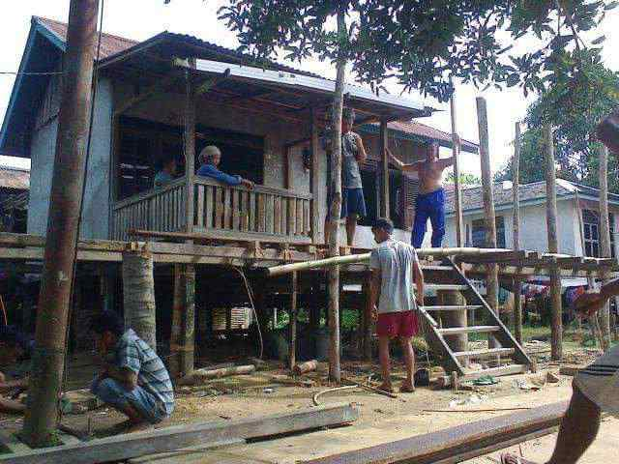

Image: 1 K egiatan b etangke, made by mutual cooperation.

- Mensurong (conductivity goods), Mensurong is conducting goods - goods. These items are assistance and equipment for prospective brides from the prospective bridegroom with the intention of preparing for the wedding reception day, these items are in the form of: Customary money, delivery money, a warm bed, a set of bride clothes, a set of madi tools, Pesalin Orang Tua (Woman), and Langkah Batang. Usually the delivery items delivered were adjusted to of the traditional Malay brides in the area.
- Bejaet (sewing). The bride culture used to use the Bejaet culture , because in the past there was still little selling bedding, such as sheets, blankets, pillows, mosquito nets and so on. In this Bejaet custom, some women make the equipment in working together, which will later be used for the bride and groom in the bridal room.
But at this time Bejaet's activities were no longer found at weddings, this was because the equipment used to the bridal room, such as pillowcases, sheets, blankets and mosquito nets and other equipment had been sold and available in the market. So when the Mensurong event is usually the men directly buy the ready-made equipment, which is sold on the market.
- Begantong (pairing or decorating the room). Begantong is the term for attaching something or hanging something on the temp, in this case a mosquito net. After the event Bejaet finished, proceed with the Begantong. There is one unique culture when the mosquito nets and bedding that have been made are neatly decorated, the bride massages into the mosquito net, facing back , then throwing coins, sweets, sugar cane and bananas into the people who are getting ready to wait in the bride's room.
- Betutok Bumu (mashing spices). In this activity, it is usually carried out on the same day as Bejaet and Begantong, the women usually share their duties to carry out these activities, according to their respective expertise.
- Manik Berias. It is an event carried out in the morning. hence the custom of bathing is carried out before the sun rises. The event equipment is in the form of: Freshwater Flour, Sabang Leaf, Mali Leaf - Mali, Petabar Leaf and long cloth. This activity is carried out to dispose of bad luck or ask for safety.
- Betangas is removing sweat and body odor and removing the aura of the bride and groom when they are married. This activity was carried out by the two brides separately in their respective homes. There are some dry equipment that must be provided when this activity is to be carried out, among which are: Mat, Long Cloth, Pot containing spices, which is then heated. Next, the bride and groom are asked to enter into the mat rolls which have been provided with a pot filled with flour on the top of the covered mat using a long cloth.

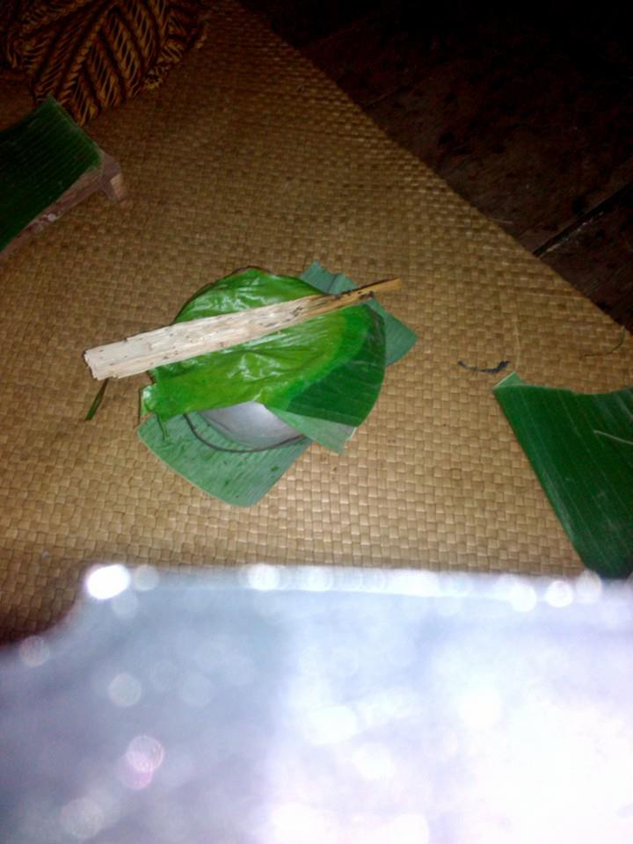
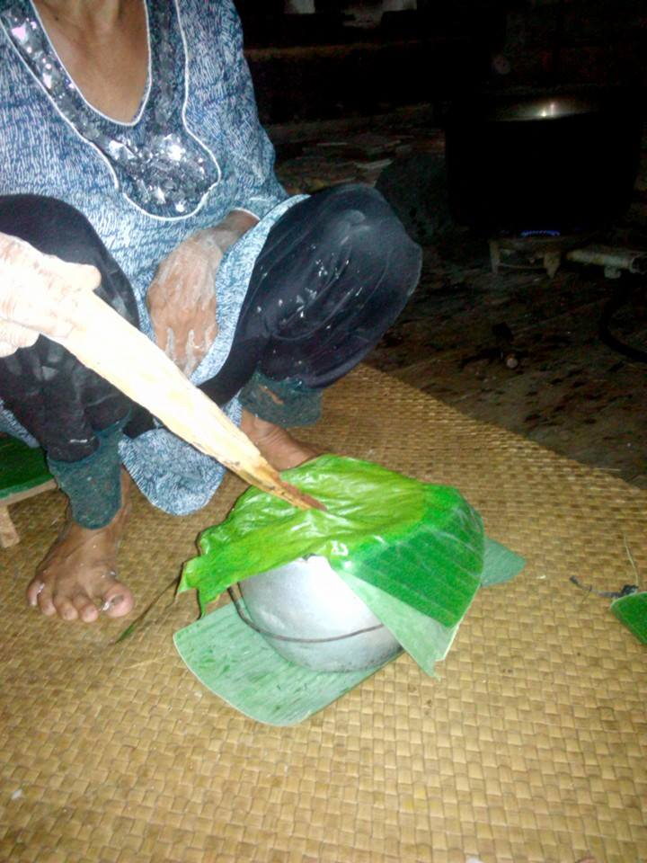

Picture: 2 & 3 pots containing Betangas spices

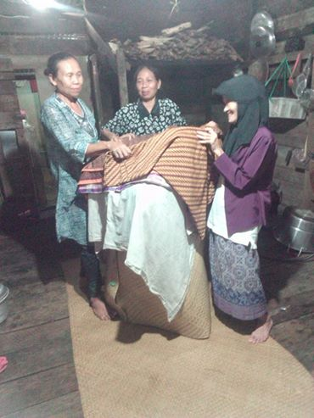
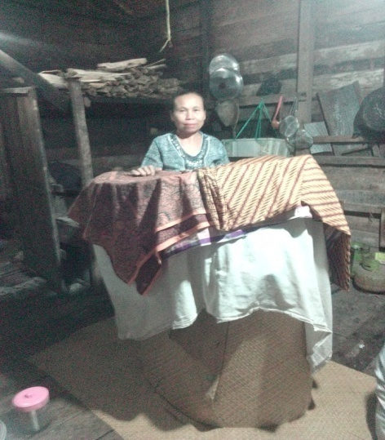

Picture: 4 Prospective brides are in a roll of mats covered with cloth

- Masang Cerengok (inai). This event is held at night . The implementation of the dating / inaugural event was carried out by the two brides in their respective homes. This is done to give color to the nails or decorate the nails of the bride and groom.
- Mullah Janor (young coconut leaves) making this leaf is an activity that people always do to make the ornaments in the aisle and as a marker for the wedding reception. This activity is carried out to decorate the aisle where the two brides sit side by side.

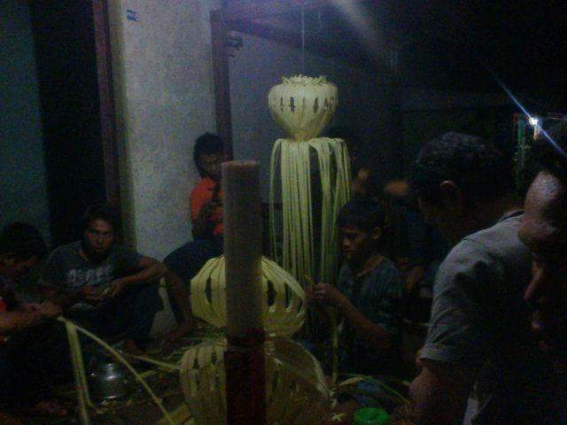

Picture:5 Mulah Janor

- Behadrah is usually a habit that is carried out at night at the wedding event this is done in the hope of adding blessings to the bride and groom, during hadrah activity people usually read the Serakal book, which contains prayers to the Prophet and praise to the Prophet.

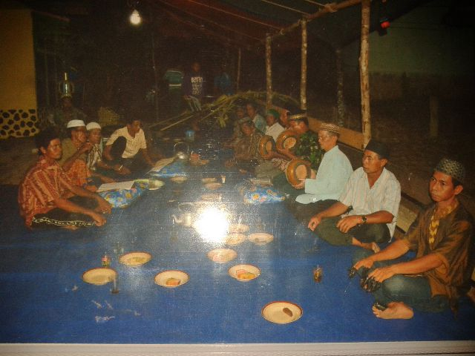
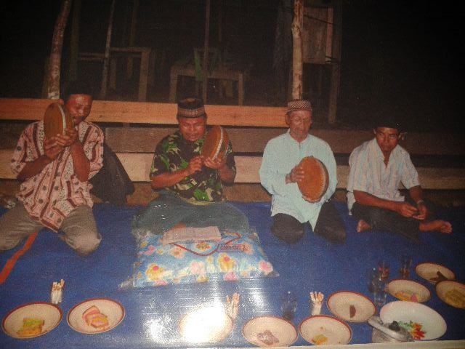

Picture:6 & 7 Behadrah
- Nyemeleh and Berapi (Slaughtering and cooking) on this activity, the men slaughter animals that will be cooked as dishes as in weddings and others seek umbut (young part of the coconut tree) be used as a vegetable, after these two materials provided women cut and cook them.
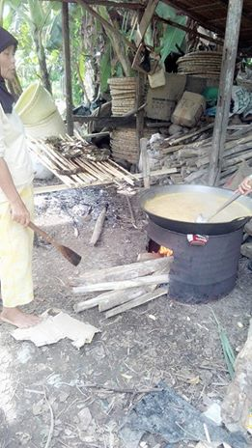
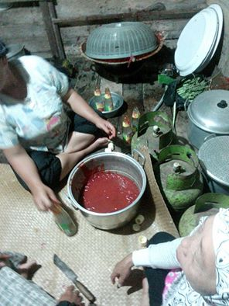

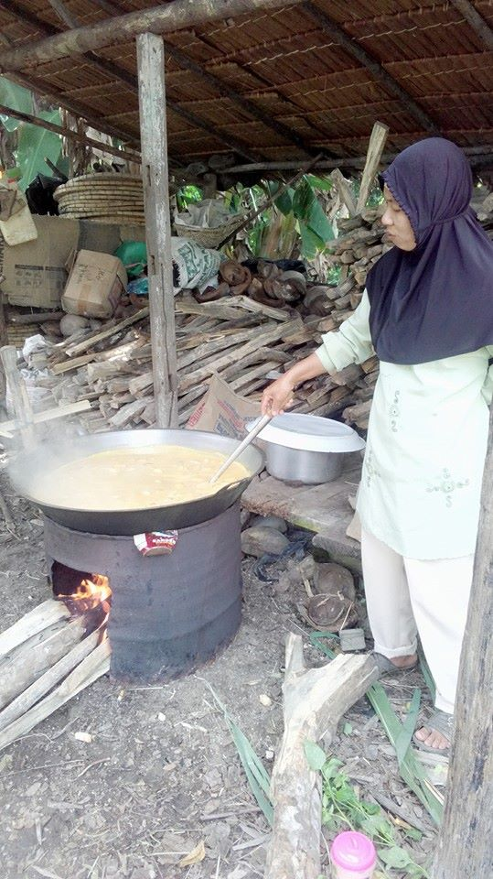

Gambar : 8,9 & 10 Berapi

- Bararak and Netak Ompong, Berarak is when the bridegroom is accompanied by Hadrah walking to the bride's house or reception, usually in front of the house a Ompong is provided, namely the gate made from coconut leaves covered with a cane. Before the Bride Groom are welcome to enter, it especially representatives of the bridegroom or bride, people dance with their machetes, which will later be used to cut the sugar cane, so this culture is called Netak Ompong.

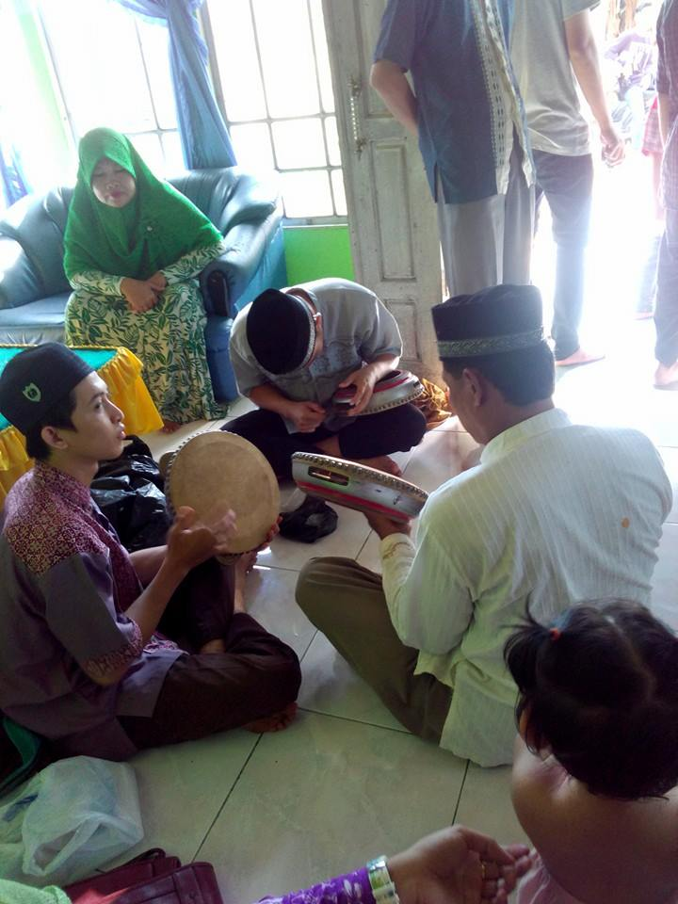

Gambar: 11 Persiapan Berarak

- Marriage contract (Ijab Qobul), for that event the marriage contract equipment requires equipment as follows: One quadrangular mat covered in yellow cloth and the fourth corners are given embroidery decorations (Sulam Betekad). A plate of sticky rice (Pulut) which is colored yellow and sprinkled with core (nyiur which has been grated and colored / mixed with brown sugar) and decorated with eggs called rice adab and a set of betel places and saliva.

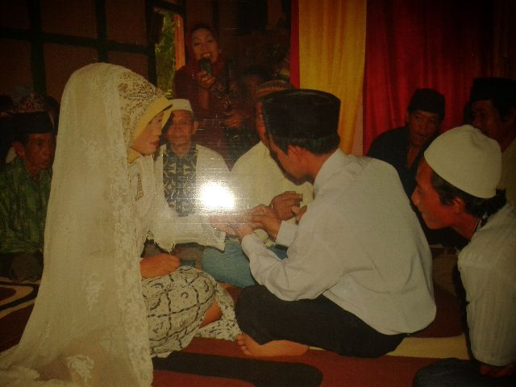
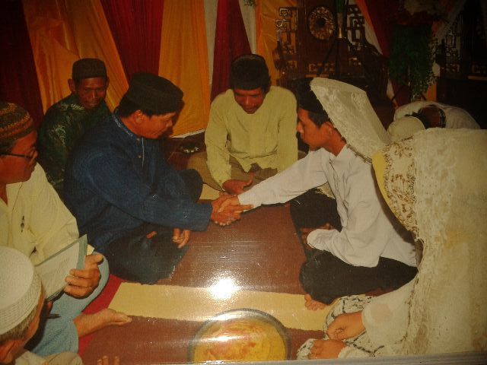

Gambar:12 Akad Nikah

- Selamatan (Reception Day) is meant by salvation is the day of the wedding reception, which is to take the bridegroom from his residence to the house of the bride's residence.
- Nopen, Japen, and Begambus. Nopen is a traditional Jepin or belangkah art that uses masks, which are always held at weddings and take place at night. The staple is usually carried out with special events without taking cover or wearing a mask. Whereas begambus is a rhyme accompanied by a musical instrument such as a guitar, which is delivered by one person. This transformation is usually carried out to entertain people who are tired of working to carry out bride activities.

Customs that have been written above are entrenched customs, most of them have been lost and rarely carried out by the surrounding community. Basically a lot of things can be learnt. One of the things is community togetherness. A sense of family will appear and grow at that time.
However, nowadays, there have been a lot of wedding services, such as bridal makeup and salons that offer bridal packages even the wedding food reservations have been widely spread everywhere. This has begun to erode existing cultures, especially culture, which is carried out in mutual cooperation. And don't be surprised if our community at this time no longer has a high sense of togetherness and mutual respect for fellow citizens. This does not only happen in urban areas but has also begun to be felt in rural areas.
Sometimes we look at the culture that exists and tend to want something practical in every way, without realizing that it will have a big impact in the future. this is what we must realize, that culture is not only a ritual but also there are things that we can learn.

CONCLUSION
Culture is the identity of a nation with the existing culture, it will shows characteristics or identity of a place and community that exist in the area. Culture is taught and preserved from generation to generation naturally the selection process by the owner's community makes the culture change.
The Urang Serawai Bride Culture is one of the cultures in the Serawai area, which is usually done at weddings. This culture starts from the introduction to the event until the wedding reception.
In the series of marriages, there are some things that have not been found anymore. This happens along with the development era, some cultures are shifted or changes along with the development of the times.
Cultural shifts that occur on one side give and facilitate the reading to make easier and practical. But on the other hand, the loss of some of the cultural routines impact on togetherness and mutual societies.
Wedding culture is usually performed in the community. The author really experience of the impact on peace and familiarity among communities in the area, with the existence of a culture full of mutual cooperation and togetherness. This is very good to be preserved in the community, as well as known by the younger generation as the successor of the existing culture.
In addition, in the culture of urang Serawai bride, there are also elements of Islam through activities of reciting the Koran, prayer, barzanji, hadrah, etc .; and local elements - even Hindu-Buddhist elements, such as the presence of nopen, toothless, coconut leaf, etc. These elements blend in the bride culture activities and make Urang Serawai's bride groom to be distinctive and attractive.

BIBLIOGRAPHY

Amin, F. (2013). Kitab Berladang. Pontianak: IAIN Pontianak Press.
Hermansyah, H. (2010). Ilmu Ghaib Kalimantan Barat. Jakarta: Kepustakaan Populer Gramedia.
Mansoer, M.D. (1970). Sejarah Minagkabau. Jakarta: Bhratara
Syahzaman, S., & Hasanuddin, H. (2003). Sintang dalam Lintas Sejarah. Pontinak: Romeo Grafika
Tibi, B. (1999). Islam, Kebudayaan dan Perubahan Sosial. Terj.Yogyakarta: Tiara Wacana.
Yusriadi, Y., & Patmawati, P. (2006). Dakwah Islam di Kalimantan Barat. Pontianak : STAIN Pontianak Press.
Downloaded at October 09, 2015 from https://id.wikipedia.org/wiki/Kabupaten_Sintang.
Downloaded at October 09, 2015 from https://id.wikipedia.org/wiki/Serawai,_Sintang.

see : https://id.wikipedia.org/wiki/Kabupaten_Sintang
see : https://id.wikipedia.org/wiki/Serawai,_Sintang
The history of the founding of the kingdom of Sintang deliberately entered the author because the author argues that the founding of the Sintang kingdom which was founded by the Malay Aji who brought Buddhist culture influenced the existing culture in the Sintang and surrounding areas including the Serawai sub-district.
In this paper the author includes the history of the entry of Islam into West Kalimantan, including the Sintang and surrounding areas, so as to give us an idea that, existing cultures existed before, which have also been influenced by Buddhist culture, after the arrival of Islam, the culture was also influenced or incorporated Islamic nuances into it, or what we usually know by the term syncretism or cultural alkulturation.

